Test Cases for Additional Features

**Test Case 1: Third-Party Login with Google Integration**

**Objective:** To verify the successful sign-in process using the third-party login (Google) feature and ensure users are redirected to the appropriate registration page based on their selection.

**Test Steps:**

1. Launch the application.
2. On the login page, locate and click on the "Sign in with Google" button.
3. A Google account selection popup will appear. Choose a valid Google account by clicking on it.
4. After account selection, a dialog with two options will appear: "Register as Candidate" and "Register as Employer".
5. Choose the desired option by clicking on it.
6. Upon selection, the user should be automatically redirected to the corresponding registration page:
   * If "Register as Candidate" was chosen, the user should be redirected to the "Edit Candidate" page.
   * If "Register as Employer" was chosen, the user should be redirected to the "Edit Employer" page.
7. Confirm that the appropriate page has loaded and the necessary fields for candidate or employer registration are displayed.

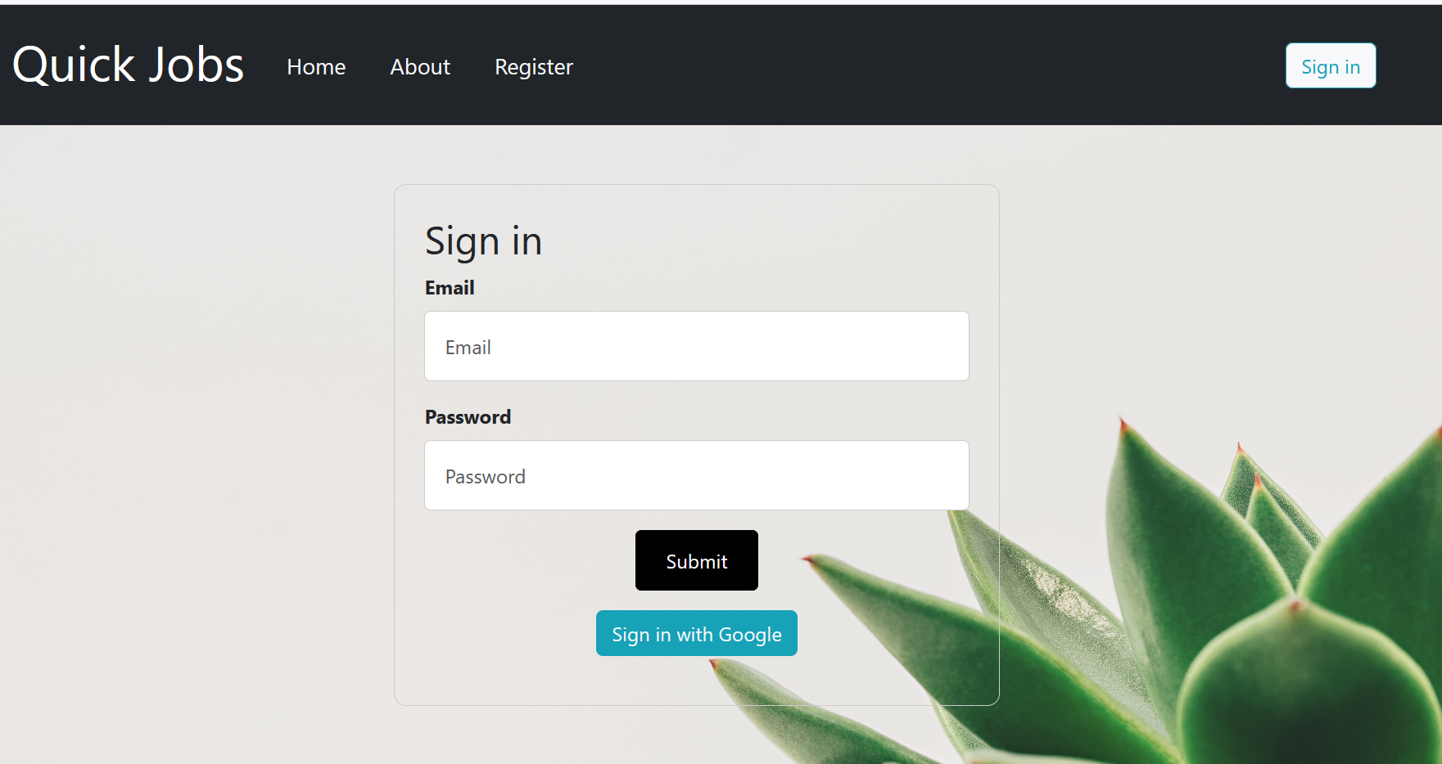

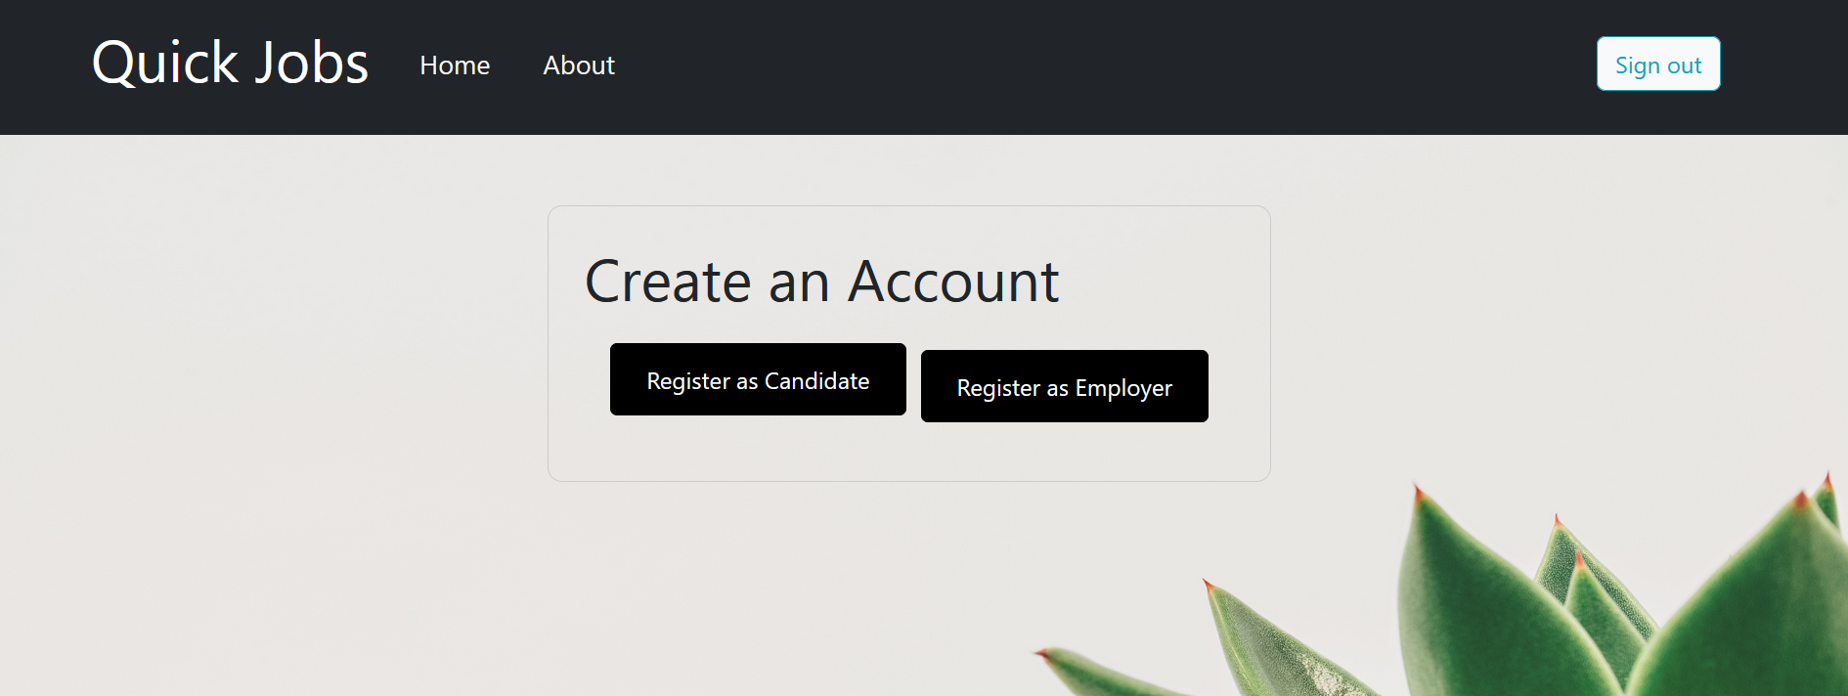

**Test Case 2: Job Search Filter**

**Objective:** To validate the functionality of the job search filter by verifying that relevant job posts are displayed based on entered keywords, and a proper message is displayed in case no matching results are found.

**Test Steps:**

1. Log in as a candidate to access the home page.
2. On the home page, locate the search bar designed for job search.
3. Enter specific keywords related to a job position title that is expected to match with existing job posts.
4. Press the "Search" button to initiate the search process.
5. If matching job posts exist in the system, they should be displayed on the page.
6. If no matching job posts are found:
   * A message with the text "No results found" should be displayed on the page, indicating the absence of matching job posts.

